**CARDIO-PULMONARY RESUSCITATION (CPR)**

**Definition**

Cardiopulmonary **resuscitation** (**CPR**) is an emergency procedure that combines chest compressions often with artificial ventilation to manually preserve intact brain function until further measures are taken to restore spontaneous blood circulation and breathing in a person who is in cardiac arrest.

Chest compressions generate a small but critical amount of blood flow to the heart and brain. This significantly improves the chances of successful resuscitation

**C-A-B**

**Compressions:** Push hard and fast on the centre of the victim’s chest

**Airway:** Tilt the victim’s head back and lift the chin to open the airway

**Breathing:** Give mouth-to-mouth rescue breaths

**ASSESS Unresponsive:** No breathing or no normal breathing (only gasping). Activate the EMS (call 911). Get the AED if available and return to the victim. If second rescuer is available send them to get help and the AED. Check Pulse: Check the victim's pulse at the carotid artery for no more than 10 seconds

**DELIVER HIGH QUALITY CPR**

* Start compressions within 10 seconds of identifying cardiac arrest.
* Compress chest at least 2 inches, 30 times on the lower half of the breastbone.
* Compress 2-handed, with one hand on top of the other Compress at a rate of at least 100 compressions per minute
* Each set of 30 compressions should take 18 seconds or less
* Allow complete chest recoil after each compression.
* Minimize interruptions in chest compressions to less than 10 seconds
* CPR ratio is 30 compressions to 2 breaths
* Ratio stays the same for one-person & two-person CPR
* In two-person CPR the rescuers should change positions after every 2 minutes

**PROVIDE EFFECTIVE BREATHS**

* Open the victim’s airway
* Use the appropriate technique to open the airway Head Tilt-Chin Lift: tilt the head back and lift the chin or Jaw Thrust If a head or neck injury is suspected
* Deliver each rescue breath over 1 second
* The victim’s chest should rise with each breath
* Avoid excessive ventilation
* Use bag-valve mask or barrier device if available
* Once an advanced airway is placed, continuous compressions are performed without pause for ventilation.
* Ventilations are delivered at a rate of 1 breath every 6-8 seconds
* If there is a pulse and the victim is not breathing: Provide rescue breathing: 1 breath every 5-6 seconds (10-12 breaths/minute)
* Attach and use AED as soon as available

[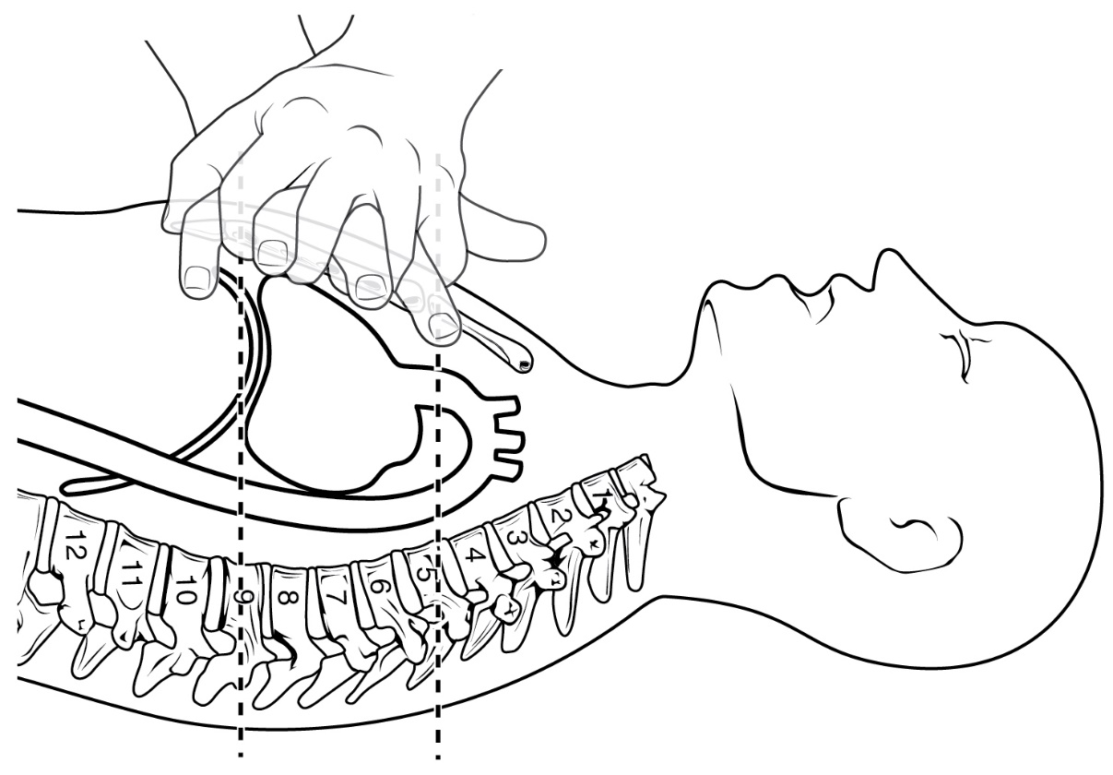](https://www.google.co.uk/url?sa=i&rct=j&q=&esrc=s&source=images&cd=&cad=rja&uact=8&ved=0ahUKEwik05vR-uvZAhXL6xQKHdMTDBoQjRwIBg&url=https://commons.wikimedia.org/wiki/File:2002_CPR_Technique.jpg&psig=AOvVaw2K85a8qi0xa4kV1zaak6C8&ust=1521121526171490)

[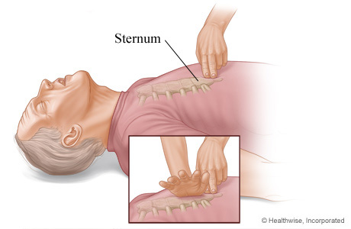](https://www.google.co.uk/url?sa=i&rct=j&q=&esrc=s&source=images&cd=&cad=rja&uact=8&ved=0ahUKEwi6v9i0-evZAhWCPxQKHbz-CRwQjRwIBg&url=https://www.webmd.com/first-aid/cpr-in-adults-positioning-your-hands-for-chest-compressions&psig=AOvVaw2K85a8qi0xa4kV1zaak6C8&ust=1521121526171490)

[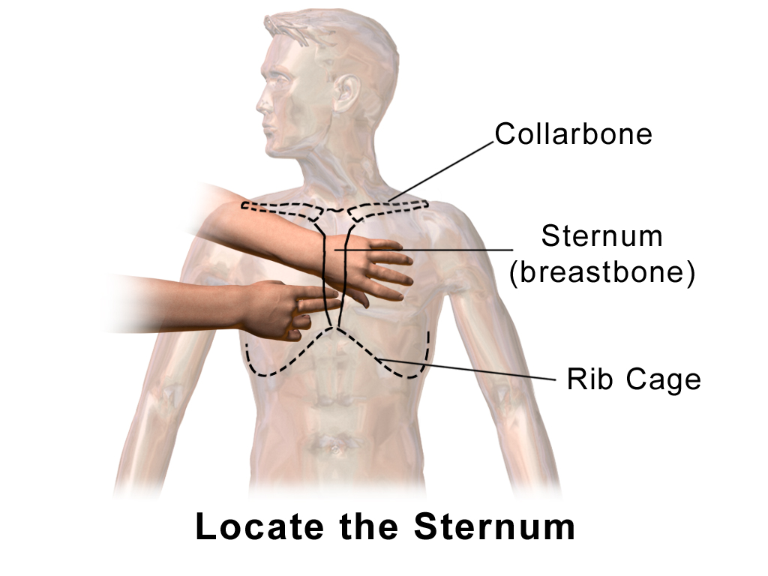](https://www.google.co.uk/url?sa=i&rct=j&q=&esrc=s&source=images&cd=&cad=rja&uact=8&ved=0ahUKEwjp7eXI-evZAhUBvBQKHTXSARsQjRwIBg&url=https://commons.wikimedia.org/wiki/File:CPR_Adult_Chest_Compression_Sternum.png&psig=AOvVaw2K85a8qi0xa4kV1zaak6C8&ust=1521121526171490)

[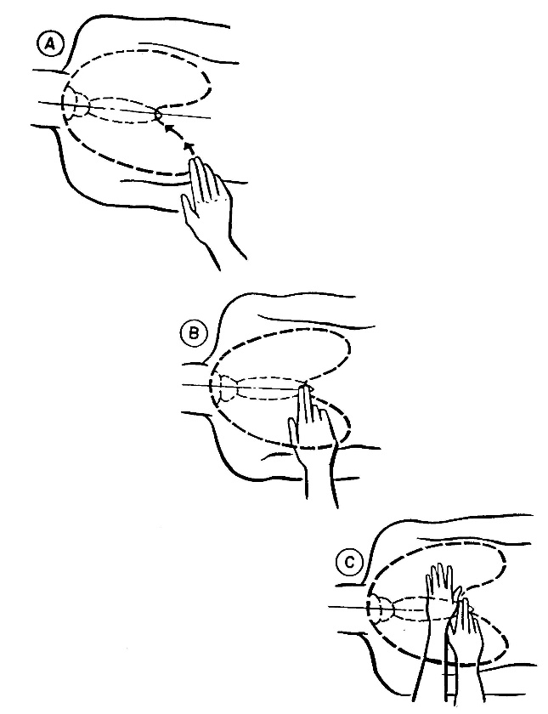](https://www.google.co.uk/url?sa=i&rct=j&q=&esrc=s&source=images&cd=&cad=rja&uact=8&ved=0ahUKEwjnjYyz-uvZAhVCchQKHY9wBiIQjRwIBg&url=http://nursing411.org/Courses/MD0532_Cardiopulmonary_Resuscitation/4-01_Cardiopulmonary_Resuscitation.html&psig=AOvVaw2K85a8qi0xa4kV1zaak6C8&ust=1521121526171490)

**CPR for Infants (Age <1)**

|  |  |
| --- | --- |
| Step 1 | **1. Shout and Tap**  Shout and gently tap the child on the shoulder. If there is no response and not breathing or not breathing normally, position the infant on his or her back and begin CPR. |
| http://depts.washington.edu/learncpr/images/infant5.gif | **2. Give 15 Compressions**  Give 30 gentle chest compressions at the rate of 100-120/minute. Use two or three fingers in the center of the chest just below the nipples. Press down approximately one-third the depth of the chest (about 1 and a half inches). |
| Step 3Step 2 | **3. Open the Airway**  Open the airway using a head tilt lifting of chin. Do not tilt the head too far back   |  |  | | --- | --- | |  | **4. Give 2 Gentle Breaths**  If the baby is not breathing or not breathing normally, cover the baby's mouth and nose with your mouth and give 2 gentle breaths. Each breath should be 1 second long. You should see the baby's chest rise with each breath. | |
|  |  |